

Name : Wong Chang Huei

Login ID : R03412913@oasis-portal.my

Course title : Executive Diploma in Culinary Arts & Hospitality Management

Subject Code : CA03 International Cuisine

Submitted date: **7/September / 2017**

**Table of Contents**

|  |  |  |
| --- | --- | --- |
| **No** | **Details** | **Page** |
| 1 | Executive Summary | 2 |
| 2 | Introduction | 3-4 |
| 3 | Assignment Question | 5-11 |
|  | Part 1 | 5 |
|  | Part 2 | 7 |
|  | Part 3 | 10 |
|  | Part 4 |  |
| 4 | Conclusion | 12 |
| 5 | References | 13 |
|  | Appendix |  |

**Executive Summary**

In this assignment we will learn about the purpose of this unit is to be able to understand International Cuisine within Culinary Arts and Hospitality Management

We will need to choose one dish from each cuisine. The cuisines are Chinese cuisine, Indian Cuisine, Western Cuisine. From we will need to recreate or alter the original recipe into our own recipe.

This exercise has given me the chance to learn about the difference cuisines and the factors that makes each dish special. The Chinese cuisine will most using pot to cook and have soup

**Introduction**

International Cuisine means is the food of the different cooking at different country. Each country its own cooking/cuisine and each cuisine is an art in itself just like Chinese, French, , Thailand, India come for other country.

Chinese Cuisine:

-Fried rice

-plain noodle

-barbecued pork

-pig’s knuckle

-spicy hot noodles

-sliced noodles

-preserved meat

-bolied salted duck

French Cuisine:

-Coquilles Saint-jacques

-Baked Camembert

-Moules Marinieres

-Buckwheat Crepes

-Lemon meringue pie

-Beef Burgundy

-Ereme Brulee

-Cognac shrimp

Thailand Cuisine:

-Tom Yum Goong (Spicy Shrimp Soup)

-Som Tum (Spicy Green Papaya Salad)

-Tom Kha Kai (Chicken in Coconut Soup)

-Gaeng Daeng (Red Curry)

-Pad Thai (Thai style Friend Noodles)

-Khao Pad (Fried Rice)

-Pad Krapow Moo Saap(Fried Basil)

-Kai Med Ma Muang (Chicken with Cashew Nuts)

India Cuisine:

-Navratan Korma(Nine Gem Curry)

-Tandoori Chicken

-Sambar

-Ras Malai

-Carrot Halwa

-Butter Chicken

-Chana Masala

-Chicken Tikka

**Assignment Questions**

You should create your own dish from each international cuisine listed.

Required:

Choose one dish for each cuisine:

1. Chinese cuisine
2. Indian cuisine
3. Westen cuisine

1. Chinese cuisine

God fried rice

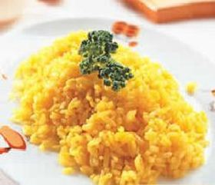

Ingredients：

1 bowl rice

2 yolk

Half Spoon salt

Instruction

1. egg yolk break up into egg.

2. Place the rice in the container and add the egg yolk of the practice 1 to stir until the rice is golden brown.

3. hot oil pan, the practice of 2 rice fry until the rice grain was loose, add the right amount of salt seasoning can be wok food.

DIY Apple Fried Rice

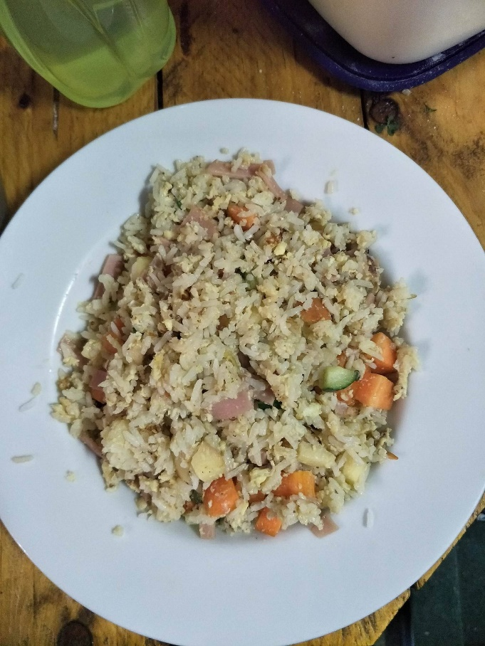di

Ingredients：

Half of radish

Half of apple

¼ of cucumber

2 bowl rice

2 egg

Half Spoon salt

1 Spoon Chicken powder

2 pieces of Ham

A little bit of sugar

Instruction

1. Put some oil on pot and put the garlic
2. Mix the eggs and the rice together
3. Cut the radish , apple , ham and cucumber to dice
4. After cut put it in the pot and fried it
5. After fried put the rice already mix wait egg and put the seasoning fried it 3-4 minuted
6. Indian cuisine

Rumali Roti

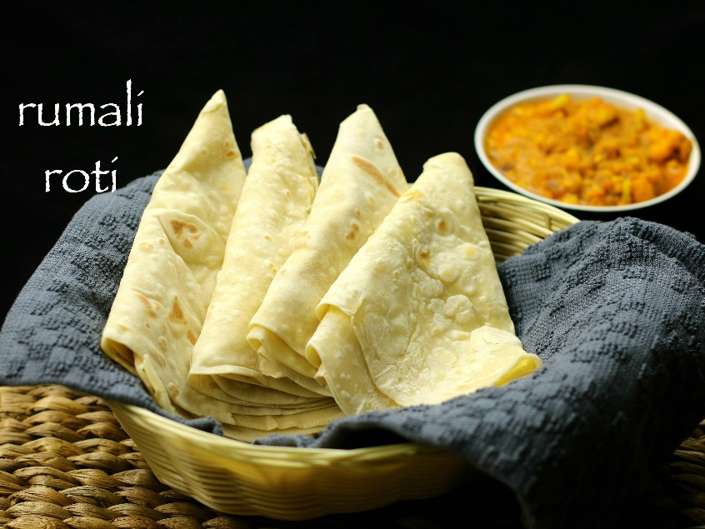

Ingredients:

2 cups maida/ all-purpose flour / plain flour

Salt to taste

2tsp oil

¾ cup warm milk, add as required to knead dough

¼ cup maida / all-purpose flour to dust

1 cup water

1 tsp salt

1 cup= 255 ml

Instruction

rumali roti dough recipe:

1. first of all, in a large mixing bowl, take 2 cups of maida.
2. add pinch salt and a teaspoon of oil.
3. add warm milk little by little and start to knead.
4. knead for atleast 15 minutes.
5. finally, grease the dough with a tsp of oil to prevent from drying.
6. in conclusion, cover with moist cloth and rest for atleast 20 minutes.

rumali roti recipe:

1. pinch a small sized ball dough, roll and flatten it.
2. also dust with some plain flour.
3. furthermore, roll it into a thin circle.
4. roll as thin as possible.
5. stretch little so that it become thin.
6. roll the rumali roti carefully over the rolling pin

roasting roti recipe:

1. take kadai or chapathi tawa and heat for 2 minutes.
2. then reverse the kadai and heat further more a minute.
3. sprinkle some salt water over kadai.
4. now slowly unroll the rumali roti over hot kadai.
5. after 30 seconds you can see bubbles forming over roti.
6. so flip off and cook the other side.
7. meanwhile, with a help of towel gently press.
8. once the golden brown spots start appearing, the roomali roti is done.
9. serve roti immediately with curry of your choice.

DIY Roti banana

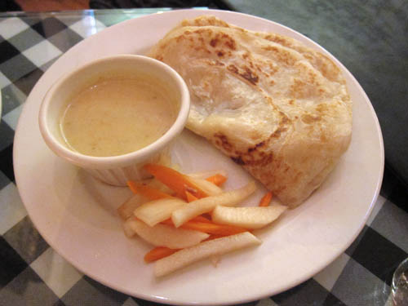

Ingredients:

2cup of 250g flour, 1/3 spoon fine salt, 1 banana, 1 spoon planta 1spoon condensed milk half cup of water

Instruction

1. First put two cups of flour (250 g / cup)
2. Then put, 1/3 teaspoon of fine salt, do not put too much, or too salty
3. And then put half a glass of water, the dough is too hard to put more, but do not put too much
4. Put a spoon planta
5. Make the banana to rotten
6. Put a teaspoon of condensed milk
7. Mix it together
8. Finally put the dough under the image of the ball below, and painted a layer of top blue at the top of him
9. Cover the cling film for 6 hours or overnight. 10 minutes before frying.
10. Apply a layer of oil and then take a dough out, after opening the dough off, the thinner the better.
11. Then the dough is stretched and then made into a bar
12. And then rolled from the ends into the following shape.
13. Finally, put the curled ends together and press
14. And so on to fry the time, it is flat to almost palm size
15. Finally, put a teaspoon of oil and fry until the micro-focus can be
16. Western cuisine

Carbonara pasta

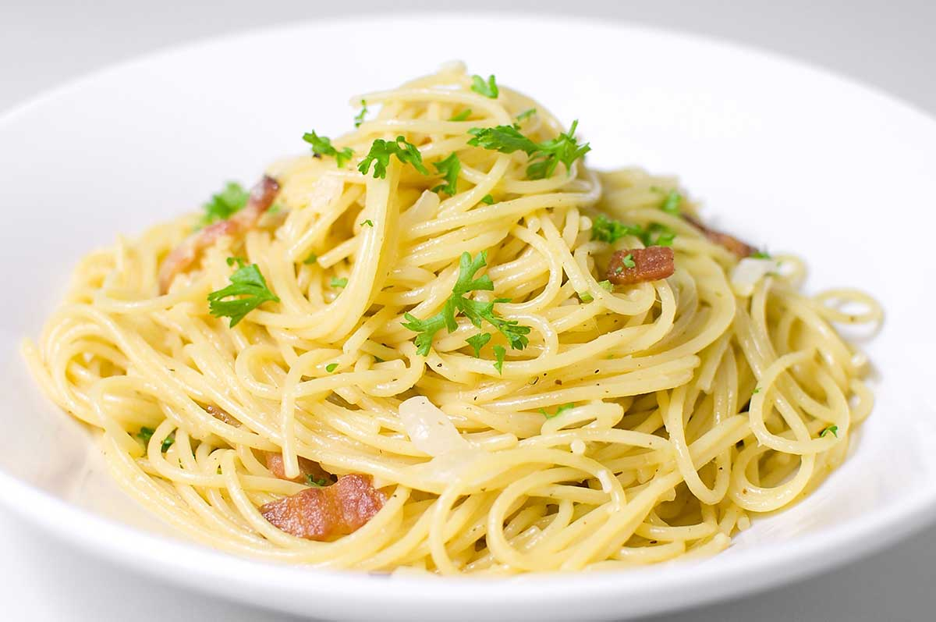

Ingredients:

* 3 large free-range egg yolks
* 40 g Parmesan cheese , plus extra to serve
* 1 x 150 g piece of higher-welfare pancetta
* 200 g dried spaghetti
* 1 clove of garlic
* extra virgin olive oil

Instruction:

1. Put the egg yolks into a bowl, finely grate in the Parmesan, season with pepper, then mix well with a fork and put to one side.
2. Cut any hard skin off the pancetta and set aside, then chop the meat.
3. Cook the spaghetti in a large pan of boiling salted water until al dente.
4. Meanwhile, rub the pancetta skin, if you have any, all over the base of a medium frying pan (this will add fantastic flavour, or use 1 tablespoon of oil instead), then place over a medium-high heat.
5. Peel the garlic, then crush with the palm of your hand, add it to the pan and leave it to flavour the fat for 1 minute. Stir in the pancetta, then cook for 4 minutes, or until it starts to crisp up.
6. Pick out and discard the garlic from the pan, then, reserving some of the cooking water, drain and add the spaghetti. Toss well over the heat so it really soaks up all that lovely flavour, then remove the pan from the heat.
7. Add a splash of the cooking water and toss well, season with pepper, then pour in the egg mixture – the pan will help to cook the egg gently, rather than scrambling it. Toss well, adding more cooking water until it’s lovely and glossy.
8. Serve with a grating of Parmesan and an extra twist of pepper

DIY Carbonara banana pasta

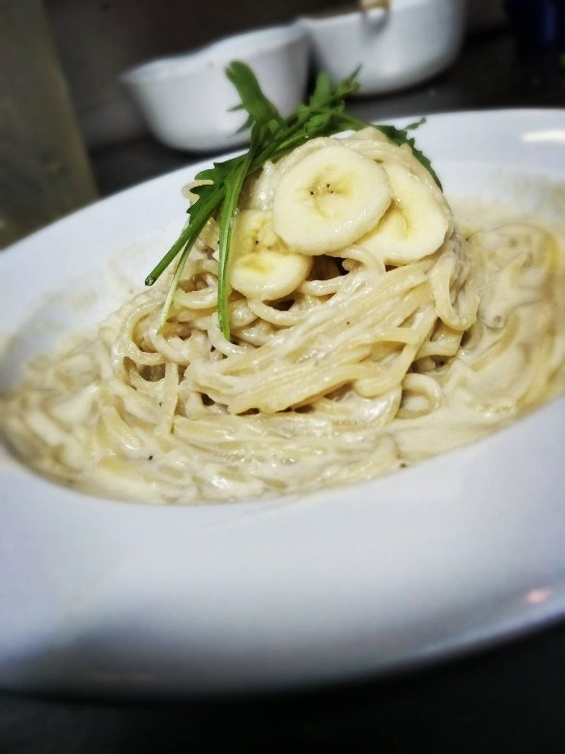

Ingredients: 2 banana , 4 pieces of rock , 1package of pasta 176g , 50g cream , half of apple ,1yolk , Half Spoon salt ,1 Spoon Chicken powder and a little bit of sugar

Instruction:

Frist Make the banana and apple stir into water, put banana and apple have be water in the pot and put the pasta , the cream and the season and cook it in 3-4 minute

**Conclusion**

This tells us that being a chef is not easy, we will need to learn about the ancient people how they do the food and what we could do to make it new and easy to produce including the methods. As a Chinese, we have one word that is to keep the traditions alive and not to break the traditions (保留传统 打破传统).

The factors that influence international are cuisine because in different parts of the world, the soil, climate and vegetation differ. Thus, the availability of plants and animals in different regions vary. Accordingly people choose the ingredients and spices that go into making the food. Historically, that is what influenced the different cuisines of different places. Places located close to the sea depended much on sea food. People living near agricultural lands depend on ingredients from those sources. Also, choices of ingredients are affected by affordability. All these factors influence the eating patterns and thus differences arise in different parts of the country

In this conclusion we know the food is the important in our life, and the food can inherited to our grandson. The food also can propagate to other country and expression that different food different culture.

**References**

Jamie oliver name, unknown date. Online source, Gennaro's classic spaghetti carbonara. Retrive from: <http://www.jamieoliver.com/recipes/pasta-recipes/gennaro-s-classic-spaghetti-carbonara/>

Hebbars Kitchen, September 9,2016. Online source, Rumali roti recipe | Romali Roti recipe | Easy roti recipe. Retrive from: <http://hebbarskitchen.com/roomali-roti-rumali-roti-recipe/>

心食谱(Heart recipes), unknown date. Online source, God fried rice.Retrive from: <http://www.xinshipu.com/zuofa/49544>